6G5Z2107: Web Design and Development

# Lab 08 – Databases and Remote Storage

John Darby

# Objectives

1. Read and understand PHP code that creates simple MySQL database tables
2. Read and understand PHP code that interacts with database tables to generate page content
3. Extend existing PHP code to create new pages making use of new database interactions within a multi-page login-driven site

The aim of today is to reinforce the concepts covered in this week’s lecture and prepare for our use of database tables in 2CWK50.

# Exercise 1: One Database, Multiple Scripts

This week we looked at a multi-page login-driven version of the “myfavouritenumber.com” website where user data is stored in database tables. You can access and test the site via Mudfoot:

* <http://mudfoot.doc.stu.mmu.ac.uk/students/john_student/PD3/>

Your first task this week is to read the code and understand how each script is working. This process will take some time, but it’s very important: 2CWK50 and the later tasks in this lab draw heavily on the ideas and techniques in these scripts. **Please complete the questions on the following page by** **typing your answers into this Word document and saving it to your H: drive so that your tutor can discuss your answers with you.**

Here are some tips for getting the most out of reading the code:

* Read the scripts in the order suggested by the questions below
* Read each script in full to identify what you do understand as well as the bits you don’t
* Run and test the script to see how it behaves (either on Mudfoot, or locally on Xampp)
* Look for where the HTML you are seeing in your browser is echoed out by the script
* Read the comments in the code carefully
* Refer back to lecture slides as you read
* Look up new or unfamiliar syntax with an Internet search (and prioritise links to good resources like the online PHP manual and w3schools)
* Refer back to code listings from previous weeks to check familiar concepts you’re still a bit unsure about
* Discuss the code with a neighbour
* Ask your tutor for help

## **create_data.php** – read the script then attempt the following questions

|  |  |
| --- | --- |
| Question: What are the values stored inside the following 3 variables: $dbhost, $dbuser, $dbpass   |  | | --- | | Answer: | |
| Question: What is the name of the database created by this script?   |  | | --- | | Answer: | |
| Question: What is the name of the first table created by this script?   |  | | --- | | Answer: | |
| Question: How many rows are inserted into the first table?   |  | | --- | | Answer: | |
| Question: What is the name of the second table created by this script?   |  | | --- | | Answer: | |
| Question: What data type is used to store the contents of the "value" column?   |  | | --- | | Answer: | |
| Question: How many rows are inserted into the second table?   |  | | --- | | Answer: | |

## **sign_in.php** – read the script then attempt the following questions

|  |  |
| --- | --- |
| Question: We have to call session_start() before we can access session data through the $_SESSION superglobal array. Why is there no call to session_start()in this script? (hint: skip to the next question if you get stuck, then come back to this one)   |  | | --- | | Answer: | |
| Question: Give a brief description (2 sentences max) of what the header.php script does   |  | | --- | | Answer: | |
| Question: How does sign_in.php decide if the current user is signed in?   |  | | --- | | Answer: | |
| Question: Find the SQL statement executed by this file and copy it in below   |  | | --- | | Answer: | |
| Question: Describe in words what the above statement does   |  | | --- | | Answer: | |
| Question: Why is it impossible for the statement to return more than 1 row?   |  | | --- | | Answer: | |
| Question: Give a brief description (1 sentence max) of what the footer.php script does   |  | | --- | | Answer: | |

## **sign_up.php** – read the script then attempt the following questions

|  |  |
| --- | --- |
| Question: Think back to the two tables that were created in create_data.php (remind yourself by looking at the code if necessary). In words, what would be the basic operation that a sign_up.php script would need to perform?   |  | | --- | | Answer: | |
| Question: Find the SQL statement executed by this script and copy it below   |  | | --- | | Answer: | |
| Question: Would this statement return any data?   |  | | --- | | Answer: | |
| Question: Based on your previous answer, what are the possible values returned by the call to mysqli_query() (stored in $result)?   |  | | --- | | Answer: | |

## **sign_out.php** – try to answer this question **before** you read the script

|  |  |
| --- | --- |
| Question: The site uses session data to keep track of whether individual users are logged in. Thinking back to our lecture on sessions, what would you expect to happen inside this script?   |  | | --- | | Answer: | |

## **all_favourites.php** – read the script then attempt the following questions

|  |  |
| --- | --- |
| Question: Find the SQL statement executed by this file and copy it in below   |  | | --- | | Answer: | |
| Question: Describe in words what the above statement does   |  | | --- | | Answer: | |
| Question: Would this statement return any data?   |  | | --- | | Answer: | |
| Question: Based on your previous answer, what will be returned by the call to mysqli_query() (stored in $result)?   |  | | --- | | Answer: | |
| Question: What is returned by a single call to mysqli_fetch_assoc()?   |  | | --- | | Answer: | |

## General

|  |  |
| --- | --- |
| Question: Three mysqli_ functions are called by the following files: sign_in.php, sign_up.php, all_favourites.php. These functions control: i) opening the connection to the MySQL server; ii) executing a query; iii) closing the connection to the MySQL server. Name these 3 functions:   |  | | --- | | Answer: | |

# Exercise 2: Implementing show_favourite.php

In this second exercise, you’re going to implement the show_favourite.php script. The job of this script is to show a signed in user their favourite number (or prompt them to set one up if they don’t have one). You can see how the script should work by testing it on Mudfoot.

Download the exercise files for this week from Moodle, and copy the them into your xampp/htdocs/ folder. Run the create_data.php script and check that you can get the site working locally. You will notice that show_favourite.php (and set_favourite.php, see also the next exercise) haven’t been implemented. Your task is to add code into the show_favourite.php script so that it works properly (see image, and test on Mudfoot).

You should consider the following when implementing your show_favourite.php script:

1. 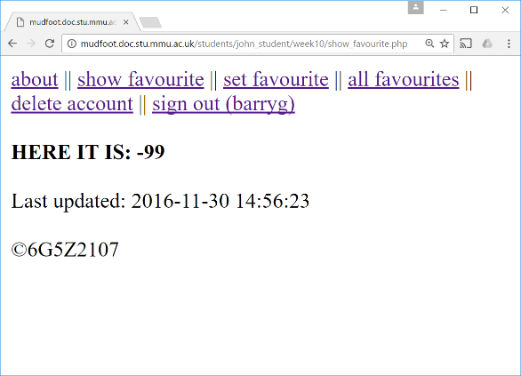How to check the user is logged in and what to do if they aren’t.
2. Which table you need to interact with (and how) in order to get the information you need.
3. The three mysqli calls you will need in order to:
   * Connect to the MySQL server
   * Execute your query
   * Close the connection
4. What will be returned by your query and how you can make use of this value in your script.
5. What will happen for users who are logged in but haven’t yet set up a favourite number.

# Exercise 3: Implementing set_favourite.php

In this final exercise, you will implement the missing set_favourite.php script. The job of this script is to let a signed in user change their favourite number (or set it up for the first time). You can see how the script should work by testing it on Mudfoot.

**[**If you haven’t already attempted exercise 2: Download the exercise files from Moodle, and copy the them into your xampp/htdocs/ folder. Run the create_data.php script and check that you can get the site working locally. You will notice that set_favourite.php (and show_favourite.php, see also the previous exercise) have not been implemented.**]** Your task is to add code into the set_favourite.php script so that it works properly (see image, and test on Mudfoot).

You should consider the following when implementing your set_favourite script:

1. 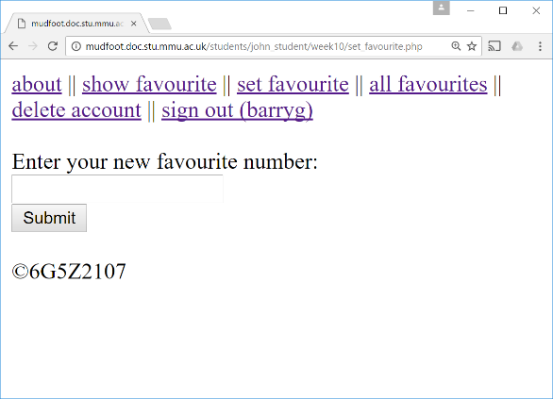How to check the user is logged in and what to do if they aren’t.
2. Which table you need to interact with (and how) in order to store the new number:
   * What query will you need if the user already has a favourite number?
   * What query will you need if they don’t?
   * What query will let you decide between the previous two options?
3. What will be returned by your queries and how you can make use of these values in your script.

# Help! I don’t know what to do!

Don’t panic!

There are plenty of resources available, including the following, which are all great starting points:

* The lecture slides (available on Moodle) which recap what we covered in the lecture
* w3schools MySQL tutorial (we are using the procedural mysqli interface): <http://www.w3schools.com/php/php_mysql_intro.asp>
* The PHP manual’s pages on the mysqli extension (we are using the procedural interface): <http://php.net/manual/en/book.mysqli.php>
* Chapter 8 and 9 of “Learning PHP, MySQL and JavaScript” by Robin Nixon (available as an e-book through the library webpages) and chapter 10 for examples of using the object-oriented mysqli interface

Now might also be a good time to look back at your notes from last year’s “Introduction to Web Design and Development” unit (and the “Information Systems” unit if you took it).

# I fancy a challenge, what do you recommend?

In the lecture, we talked about extending myfavouritenumber.com to include user profiles and a global “feed” for short text posts, including discussing suitable table designs. Try extending the existing code to incorporate this new functionality. [Be strategic: you should only attempt this extra challenge if you’re already making good progress with 2CWK50 and the skeleton code…] Start by extending create_data.php to generate the new tables and insert suitable test data. Then create a set_profile.php script that lets users enter information via a form, and view_profiles.php and view_profile.php scripts that let users browse and view member profiles (including their own). Finally, a feed.php page that lets any user see the global “feed” and post short messages to it using a simple form.